Exercise

1.



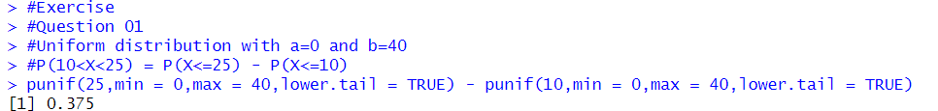

2.

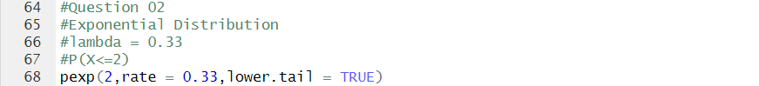

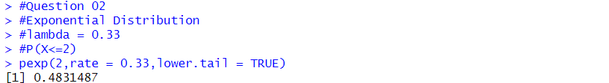

3.

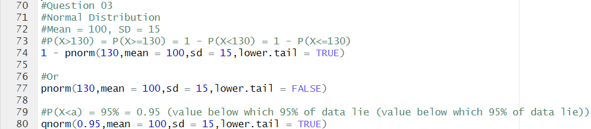

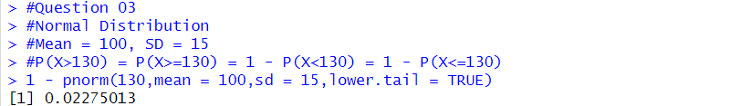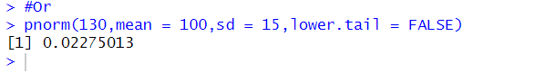

3.



